ECE 0222.1 – Electronics Circuits and Design Laboratory

PUBLIC ADDRESS SYSTEM (AUDIO AMPLIFIER)

1. THEORETICAL DISCUSSION

AMPLIFIER

This 100W audio amplifier circuit is designed using a solid-state Class AB topology based on an Output Capacitor-Less (OCL) configuration. It combines high power output capability with excellent linearity and low distortion, making it ideal for home or professional audio applications. The heart of the amplifier comprises a pair of complementary power transistors: the TIP3055 (NPN) and MJL21193 (PNP). These are selected for their high current gain, thermal reliability, and wide safe operating area, enabling efficient delivery of over 100 watts of clean power into low-impedance speaker loads.

1. Input and Differential Amplification Stage

The audio signal enters the amplifier through capacitor C1, which provides AC coupling and blocks any DC offset from the source. This signal is then fed to the base of transistor Q1, which, together with Q2, forms a differential amplifier. This stage plays a crucial role in:

* Amplifying small input signals with high linearity
* Enhancing common-mode noise rejection
* Providing stable gain and low distortion

The differential design also compares the input signal with feedback from the output, allowing the amplifier to correct errors and maintain fidelity.

1. Voltage Amplification and Biasing Network

The collector output of Q1 is directed to Q5, a voltage amplifier or pre-driver that increases signal amplitude. The gain here is sufficient to drive the output stage through the driver transistors.

* Biasing Control: Managed by Q4 and variable resistor VR1
  + Sets the quiescent current
  + Prevents crossover distortion at low signal levels
  + Ensures smooth transition between the push and pull halves of the waveform

This biasing ensures Class AB operation, which blends the low-distortion advantage of Class A with the efficiency of Class B.

1. Bootstrap and Driver Configuration

To extend the voltage swing closer to the supply rails, the amplifier uses a bootstrap circuit involving Q3 and a capacitor. This increases headroom and improves linearity at higher output levels.

* Driver Transistors: Q8 (NPN) and Q9 (PNP)
  + Amplify current to supply the output transistors
  + Operate in a complementary push-pull configuration
  + Maintain symmetrical drive for the TIP3055 and MJL21193 power transistors

This arrangement ensures high efficiency, reduced harmonic distortion, and stable thermal performance.

1. Output Stabilization and Protection Features

To enhance amplifier stability and safeguard against oscillation or erratic behavior, two key passive components are implemented in the output stage:

* Zobel Network:
  + Consists of a 10kΩ resistor and a 0.1μF capacitor in series
  + Connected from output to ground
  + Purpose: Compensates for speaker inductance and prevents high-frequency oscillations
* Series Inductor:
  + Value: 0.53μH
  + Connected in series with the speaker output
  + Purpose: Acts as a low-pass filter to block RF noise and isolates the reactive speaker load from the global feedback loop

These elements ensure reliable operation across a wide range of speakers and cable types.

1. Power Supply

The amplifier is powered by a ±35V symmetrical supply derived from a center-tapped 25V AC transformer, followed by a full-wave bridge rectifier using four 5A diodes. Large 4700µF, 50V electrolytic capacitors filter the output, providing smooth DC rails with minimal ripple. This dual-rail configuration allows for true Output Capacitor-Less (OCL) operation, enabling the amplifier to deliver a clean, full-spectrum audio signal without low-frequency roll-off. A 2A fuse and protection, while proper grounding ensures safety and noise-free performance.

1. Performance Characteristics

|  |  |
| --- | --- |
| **PARAMETER** | **VALUE** |
| Output Power (4Ω Load) | 105 W |
| Output Power (8Ω Load) | 88 W |
| Input Sensitivity | 0.5 V (suitable for most audio sources) |
| Frequency Response | 10 Hz – 10 kHz (± 1 dB) |
| Total Harmonic Distortion (THD) at 50 W | 0.07% |
| Total Harmonic Distortion (THD) at 100 W | 0.1% |

These specifications make the amplifier well-suited for clean, high-volume listening environments where sound fidelity is essential.

DYNAMIC MICROPHONE PREAMPLIFIER

This dynamic microphone preamplifier circuit is a two-stage common-emitter amplifier using general-purpose NPN transistors. It is designed to amplify the weak signal from a dynamic microphone, typically a few millivolts, up to line level for further processing. The circuit uses direct coupling between stages, enabling high gain and excellent low-frequency response, while maintaining simplicity and cost efficiency.

* 1. Input and First Amplification Stage

The microphone signal enters the preamplifier through a coupling capacitor, which serves to block DC components while allowing the AC audio signal to pass. This signal is applied to the base of the first transistor, Q1, which is configured in a common-emitter topology. This stage is responsible for:

* Amplifying the small voltage variations generated by the dynamic microphone
* Converting these variations into proportional current changes
* Providing the first gain stage for the overall signal

Q1 operates in its active region, where small variations at the base result in amplified changes in the collector current. The collector load resistor then translates this current into a larger voltage swing, effectively producing a stronger version of the original signal.

* 1. Direct Coupling and Second Amplification Stage

The collector of Q1 is directly connected to the base of the second transistor, Q2. This direct coupling offers two key advantages:

* Eliminates the need for interstage coupling capacitors
* Preserves low-frequency content, enhancing bass response

The DC operating point of Q1 sets the biasing conditions for Q2. This tight interaction helps stabilize the amplifier and ensures that both transistors remain in their linear operating region.

Q2 also operates as a common-emitter amplifier, further boosting the signal. The amplified current through Q2’s collector resistor results in a larger output voltage swing suitable for driving downstream audio stages.

* 1. Biasing and Feedback Stability

The circuit employs a passive biasing network composed of resistors connected to the power supply and ground. These resistors define the quiescent operating points for both transistors. Additionally, a resistor is placed between the emitter of Q2 and the base of Q1, forming a local feedback loop that:

* Stabilizes the DC operating point
* Reduces gain variation due to temperature or transistor parameter changes
* Improves overall linearity of the preamplifier

This feedback mechanism enables the circuit to maintain consistent performance over time and under varying conditions.

* 1. Output Coupling and Signal Delivery

The output of the circuit is taken from the collector of Q2 through a coupling capacitor. This capacitor blocks the DC voltage present at the collector and allows only the amplified AC audio signal to pass through to subsequent stages, such as tone control or power amplification.

The resulting signal has undergone two stages of voltage amplification, achieving sufficient gain to elevate microphone-level signals to standard line-level audio.

* 1. Power Supply

The preamplifier is powered by a simple 12V DC supply derived from a 9V-0-9V center-tapped transformer, followed by a full-wave rectifier using two 1N4007 diodes. The rectified voltage is filtered by a 2200µF capacitor, providing a smooth DC output. This unregulated 12V supply is sufficient for reliable operation of the preamplifier.

1. SCHEMATIC DIAGRAM
2. A diagram of a circuit

   AI-generated content may be incorrect.100W, 30V Audio Amplifier

Summary of Components:

|  |  |  |
| --- | --- | --- |
| Component | Symbols | Values and Rating |
| RESISTORS | R1 | 15K Ohms [1/2 Watts] |
| R2 | 5.6K Ohms [1/2 Watts] |
| R3 | 12K Ohms [1/2 Watts] |
| R4 | 470 Ohms [1/2 Watts] |
| R5 | 30K Ohms [1/2 Watts] |
| R6, R22, R23, R25 | 1.2K Ohms [1/2 Watts] |
| R7, R11, R12, R20, R21 | 100 Ohms [1/2 Watts] |
| R8, R9 | 560 Ohms [1/2 Watts] |
| R10, R13, R14, R19 | 10K Ohms [1/2 Watts] |
| R15, R16 | 330 Ohms [1/2 Watts] |
| R24 | 10 Ohms [1 watt] |
| R17, R18, | 0.25 Ohms [5 Watts] |
| Audio Taper Potentiometer | PT1 | 50K Ohms |
| Trimmer Potentiometer | RV1 | 1K Ohms |
| Electrolytic Capacitor | C1 | 1uF; 50V |
| Electrolytic Capacitor | C2 | 47uF; 16V |
| Electrolytic Capacitor | C5, C6 | 47uF; 50V |
| Ceramic Capacitor | C3 | 47pF; 50V |
| MKT capacitor | C4 | 0.1uF; 63V |
| 2N3904 Transistor | Q1, Q2 |  |
| MPSA56 Transistor | Q5, Q7, Q8 |  |
| MPSA06 Transistor | Q3, Q6, Q9 |  |
| BD139 Transistor | Q4 |  |
| TIP3055 Transistor | Q11 |  |
| MJL21193 Transistor | Q10 |  |
| Inductor | L1 | 0.53uH, 20T, 5mm diameter, 20 awg |
| 2 Pin Screw Terminal | J1, J2 |  |
| 3 Pin Screw Terminal | J3 |  |

1. A diagram of a circuit

   AI-generated content may be incorrect.Dynamic Microphone Preamplifier

Summary of Components:

|  |  |  |
| --- | --- | --- |
| Component | Symbols | Value and Rating |
| RESISTORS | R1 | 390k Ohms [1/4 Watts] |
| R2 | 680 Ohms [1/4 Watts] |
| R3 | 100k Ohms [1/4 Watts] |
| R4, R5 | 220k Ohms [1/4 Watts] |
| R6 | 10k Ohms [1/4 Watts] |
| R7 | 1k Ohms [1/4 Watts] |
| Electrolytic Capacitor | C1 | 1uF; 50V |
| C2, C4 | 4.7uF; 50V |
| C5 | 100uF; 50V |
| C6 | 2.2uF; 50V |
| Ceramic Capacitor | C3 | 100pF; 50V |
| BC547 [Transistor] | Q1, Q2 |  |

1. ±35V Power Supply

Summary of Components:

|  |  |  |
| --- | --- | --- |
| Component | Symbols | Value and Rating |
| Center Tapped Transformer |  | 25V-0V-25V; 4A |
| 6A10 Diodes | D1, D2, D3, D4 | 6A |
| Electrolytic Capacitor | C1, C2 | 4700uF; 50V |
| DPST Switch | SW1 |  |
| Fuse | F1 | 2A |
| Fuse Holder BLX-A |  |  |
| 2pin Screw Terminal | J1, J2 |  |
| 3pin Screw Terminal | J3, J4 |  |
| Electric Cord |  |  |

1. A diagram of a circuit

   AI-generated content may be incorrect.9V Power Supply

Summary of Components:

|  |  |  |
| --- | --- | --- |
| Component | Symbols | Value and Rating |
| Center Tapped Transformer |  | 9V-0V-9V; 750mA |
| 1N4007 Diode | D1, D2 |  |
| Electrolytic Capacitor | C5 | 2200uF; 50V |
| 2pin Screw Terminal | J4, J5, J7 |  |
| 3pin Screw Terminal | J6 |  |
| Red L.E. D | D3 |  |
| Fuse | F1 | 0.5 A |
| Fuse Holder BLX-A |  |  |
| DPST switch | SW1 |  |

1. PCB DESIGN
2. 100W, 30V Audio Amplifier

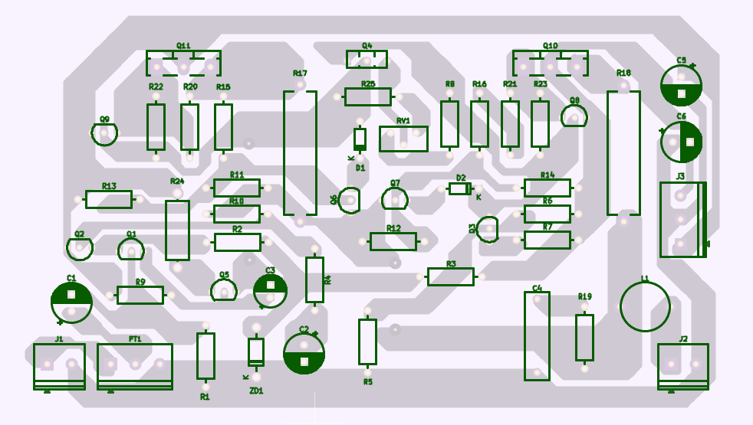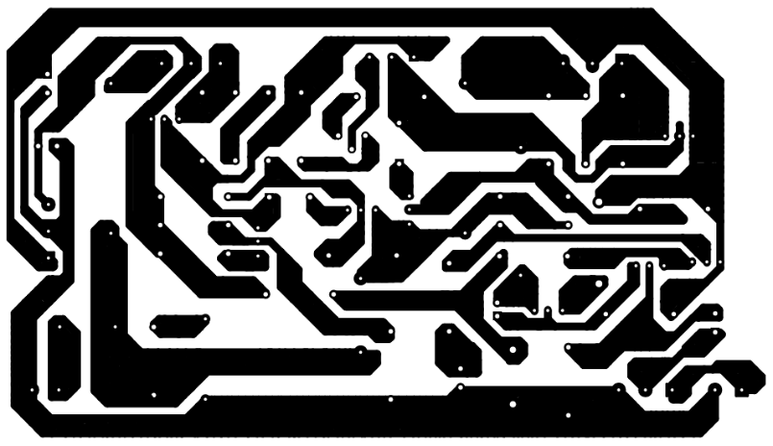

1. Dynamic Microphone Preamplifier

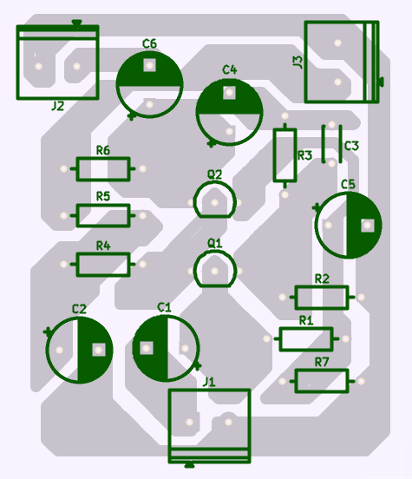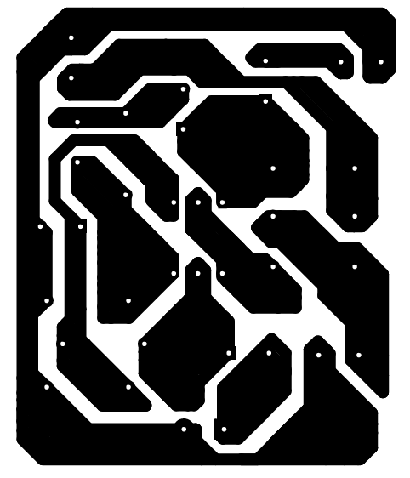

1. ±35V Power Supply

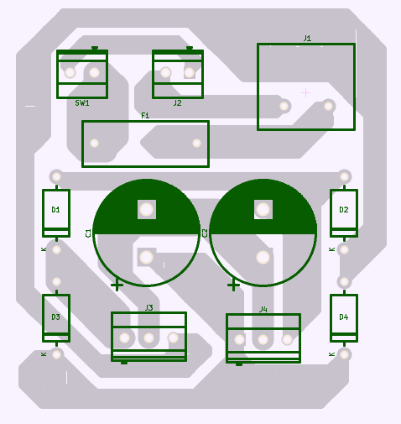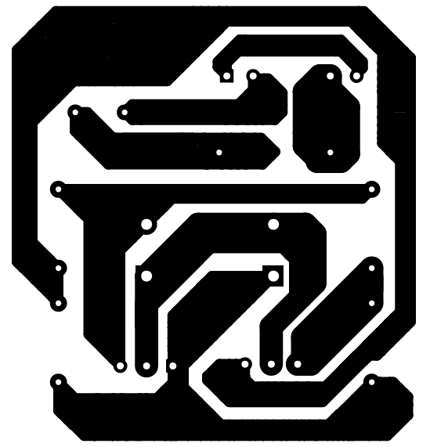

1. 9V Power Supply

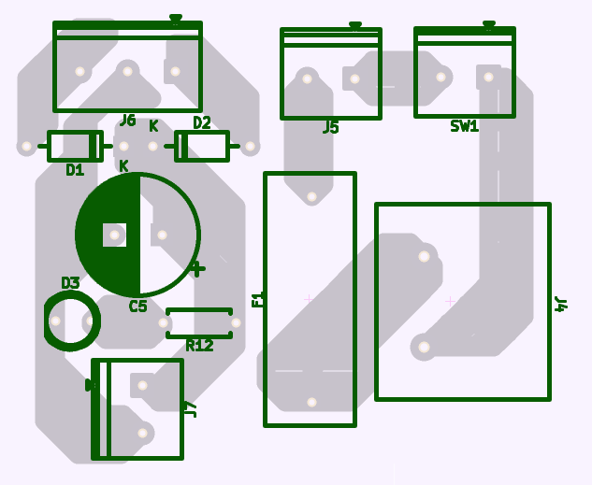

1. CIRCUIT PROTOTYPE
2. 100W, 30V Audio Amplifier

1. Dynamic Microphone Preamplifier

1. 100W, 30V Audio Amplifier (Back)

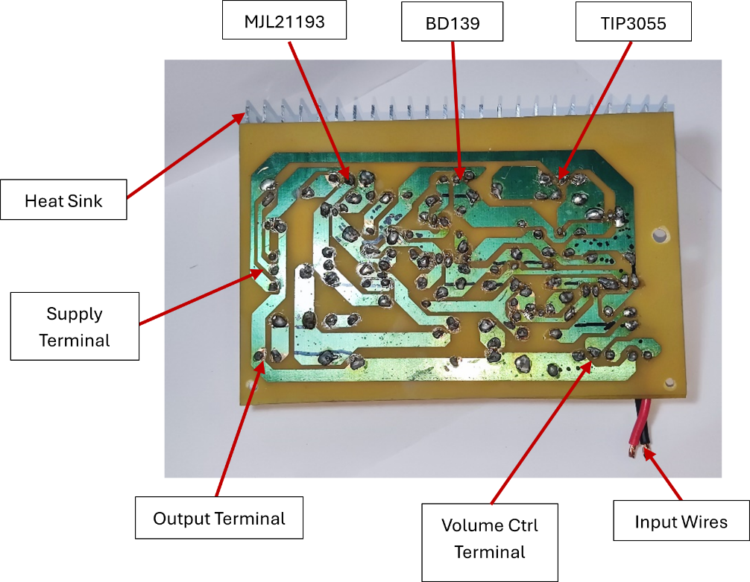

1. Dynamic Microphone Preamplifier (Back)

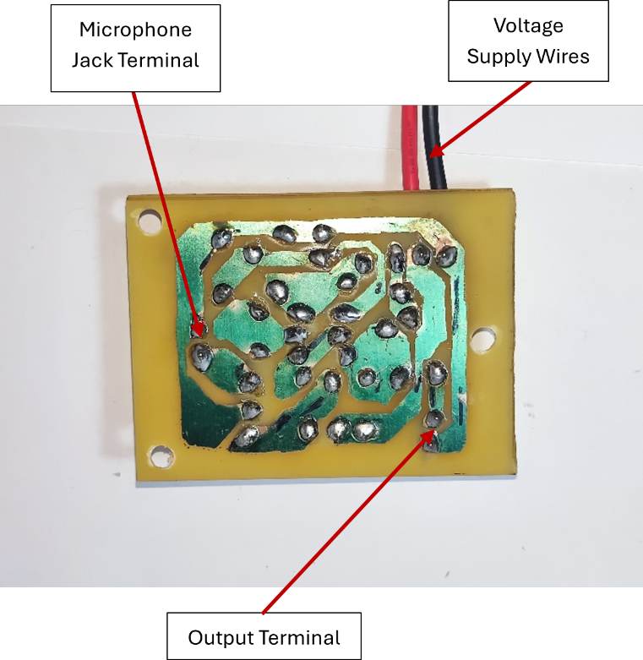

1. Inside Chassis

1. 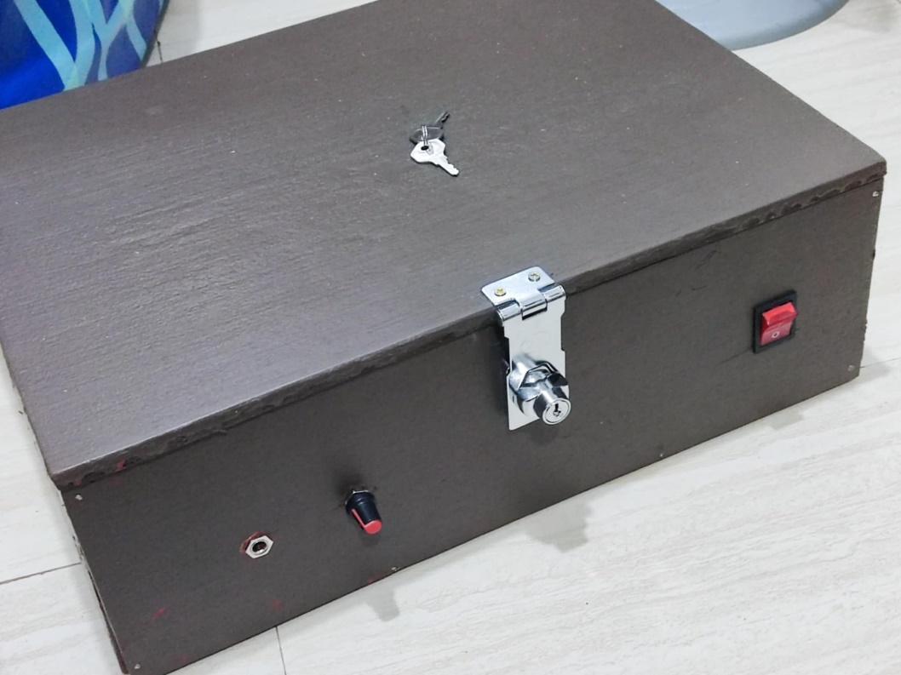Front Panel
2. Back Panel

1. TESTING AND ANALYSIS

During the testing and analysis of the circuit, Multisim was used to simulate and evaluate the preamplifier and power amplifier stages, which were connected together to form a complete audio amplification system. The purpose was to verify that both stages functioned properly in tandem to amplify a low-level audio signal. In the simulation, the input was designed to mimic the output of a dynamic microphone, which naturally produces a low-voltage signal. This made it essential for the preamplifier to boost the signal before passing it to the power amplifier. An oscilloscope was used to observe both the input and output waveforms. The output displayed a clean and amplified version of the input, with no visible distortion, clipping, or crossover issues. This confirmed that the signal was accurately processed through both stages. The seamless transition between the preamp and power amp showed that the gain and signal conditioning were working as intended. Overall, the test demonstrated that the preamplifier and power amplifier stages were effectively integrated and capable of delivering a clear and stable amplified output.

1. CONCLUSION

The development of the public address audio amplifier system was a comprehensive process that combined theoretical understanding with practical application. By integrating a high-power 100W audio amplifier with a dynamic microphone preamplifier, the project successfully demonstrated the ability to amplify low-level audio signals into clear, high-volume output suitable for public address purposes.

Throughout the project, the group encountered and overcame various challenges—from PCB etching failures to troubleshooting non-functioning preamplifier circuits. These setbacks enable us to have critical problem-solving skills, resulting in improved PCB designs, effective circuit simulations using Multisim, troubleshooting, and many more.

The final assembly within a custom-built wooden chassis showcased not only technical proficiency but also attention to aesthetic and structural details. The successful outcome reflects not only technical competence but also the persistence and collaboration of the group. This project enhanced our understanding of analog electronics, circuit design, and system integration, and served as a valuable learning experience from both an academic and practical perspective.

1. DEVELOPMENTAL PROCESS

|  |  |
| --- | --- |
| Date | Accomplishment Report |
| 04/16/2025 | * PCB Etching, the first attempt was a failure. The printed acetate was of poor quality. Some nodes were too thin and closed to each other to be etch properly * Redesigned the PCB Layout made nodes thicker and widen   the spaces between them   * Ordered another set of PCB. Etched the redesigned PCB layout. The second attempt was successful for the ±35V power supply but not for the main amplifier. Soldered the components for the power supply |
| 04/25/2025 | * Etched another set of PCBs both for the main amplifier and the power supply using baby oil method. The result was much better than using acetate. * Soldered the components for both the main amplifier and power supply. * Assembled everything from the dynamic mic to the amplifier circuit then connected to a speaker. The voice input wasn’t being amplified. * Tried to test the circuit by using a DIY jack connected to a phone. The jack wasn’t being recognized by the phone. * Bought a jack and tested again for the second time. The input from the phone was being amplified properly. The speaker produced a high sound quality |
| 05/04/2025 | * Learned that to be able to amplify the input from the dynamic mic a preamplifier is needed. * Searched for a preamplifier circuit and tested it to the main amplifier using Multisim. The circuit was working properly. * Etched the preamplifier PCB and 9V power supply PCB. Out of multiple attempts, we only manage to clearly etch one PCB. This is due to the poor print quality of the PCB layout. Used a permanent marker to improve the quality of the print. |
| 05/13/2025 | * Etched the preamplifier PCB * Designed the circuit layout inside a chassis * Looked for a chassis with the exact dimensions to fit the whole amplifier circuit. Decided to use wood to make the chassis for the amplifier and the speaker. * Bought the materials and tools for the woodworks * Started by cutting the wood into its appropriate measurements to be assembled the next meeting |
| 05/07/2025 | * Glued the wood planks speaker chassis then made a hole to fit the speaker. * Soldered the components for the preamplifier and the 9V power supply. * To test the project, connected everything including the mic, preamplifier, main amplifier, power supplies, and speaker. The project was still not working. * Troubleshoot the preamplifier and found out that the voice input from the mic wasn’t being amplified. |
| 05/13/2025 | * Assembled the wood planks for the amplifier chassis * Searched for another preamplifier circuit * Created a second preamplifier circuit * Tested using the new preamplifier circuit. The voice input was successfully amplified through the speaker. * The group celebrated by going on a hike to timberlands |
| 05/14/2025 | * Made holes for the front and back panels of the amplifier chassis * Painted the amplifier and speaker chassis * Drilled holes in the heat sink * Applied thermal paste and pads to the transistors * Made some final adjustment for the layout inside the chassis |
| 05/15/2025 | * Drilled holes to screw the PCB inside the chassis * Screwed the speaker to its chassis * Assembled the amplifier as a whole * Use screws, cable ties, glue gun for wire management |

**PHOTOS:**

DAY 1

DAY 2 DAY 3

DAY 4

DAY 5

DAY 6

DAY 7

1. MEMBER’S PARTICIPATION

|  |  |
| --- | --- |
| Members | Contributions |
| Cajayon, Charles Aldus | 1. Logistics Coordinator    1. Bought materials and equipment 2. Circuit Layout Designing 3. PCB Making    1. Etching    2. Drilling    3. Soldering 4. Chassis Making    1. Wood cutting    2. Wood assembly    3. Drilling    4. Filing    5. Painting 5. Chassis Designing |
| Calvan, Laurence King | 1. Logistics Coordinator    1. Bought materials and equipment    2. Funds Manager 2. Material/Equipment Provider 3. Circuit Layout Designing 4. PCB Making    1. Etching    2. Drilling    3. Soldering 5. Chassis Making    1. Wood cutting    2. Wood assembly    3. Drilling    4. Filing 6. Wire Management |
| Carel, Kirby Bryant | 1. Logistics Coordinator    1. Bought materials and equipment    2. Handled online purchases 2. Material/Equipment Provider 3. Circuit Testing (Multisim) 4. PCB Layout (KiCad) 5. Circuit Layout Designing 6. PCB Making    1. Drilling    2. Soldering 7. Troubleshooting 8. Chassis Making    1. Wood cutting    2. Wood assembly    3. Drilling 9. Documentation    1. 1.0 Theoretical Discussion    2. 5.0 Testing and Analysis |
| Jacobe, Jan Leander | 1. Logistics Coordinator    1. Bought materials and equipment 2. Circuit Layout Designing 3. PCB Making    1. Etching    2. Drilling    3. Soldering 4. Troubleshooting 5. Chassis Making    1. Filing    2. Painting 6. Documentation    1. 2.0 Schematic Diagram    2. 4.0 Circuit Prototype    3. 6.0 Conclusion    4. 7.0 Developmental Process    5. 8.0 Member’s Participation    6. Finalizing |
| Mallari, Raven Josh | 1. Logistics Coordinator    1. Bought materials and equipment 2. Place Provider 3. PCB Making    1. Etching    2. Drilling    3. Soldering 4. Chassis Making    1. Wood cutting    2. Wood assembly 5. Chassis Designing 6. Chef |
| Ninonuevo, Dan David | 1. Logistics Coordinator    1. Bought materials and equipment 2. PCB Making    1. Etching    2. Drilling    3. Soldering 3. Chassis Making    1. Wood cutting    2. Filing    3. Painting 4. Troubleshooting 5. Documentation    1. Photos for Developmental Process    2. 2.0 Schematic Diagram |
| Solinap, Charles Hendricks | 1. Logistics Coordinator    1. Bought materials and equipment’s 2. Place Provider 3. Circuit Searching 4. Material/Equipment Provider 5. PCB Making    1. Etching    2. Drilling    3. Soldering 6. Troubleshooting 7. Chassis Making    1. Wood cutting    2. Wood assembly    3. Drilling    4. Filing    5. Painting 8. Chassis Designing 9. Documentation    1. Outline    2. Data Manager    3. 3.0 PCB Design    4. 4.0 Circuit Prototype |